Doing Business in Historic Lapeer
If you are starting a new business in or relocating an existing business to Downtown Lapeer, you may have questions on what is required in order to get started, and what services are available to assist you.
Contact Information:
DDA Executive Director, James Alt 810-728-6598
james@lapeerdda.com
www.downtownlapeer.com

LDC Executive Director, Quinton Bishop 810-667-0080
patricia@lapeerdevlopment.com
www.lapeerdevelopment.com

Building Department,
Darryl Oliver, Building Official 810-245-9621
doliver@ci.lapeer.mi.us
www.ci.lapeer.mi.us

Planning Department 810-664-4553

City Clerk, Romona Sanchez 810-664-5231
rsanschez@ci.lapeer.mi.us
www.ci.lapeer.mi.us

Before You Start: If you need help
establishing a Business Plan, applying for
a small business loan, or are interested in
taking business-related classes, the
Lapeer Development Corporation (LDC)
may be able to help; see Contact
Information to the right.

For more information or for more copies of this informational sheet, please visit www.downtownlapeer.com and go to the “business” tab.

An overview of the information found in this packet can be summarized through the flow chart below:
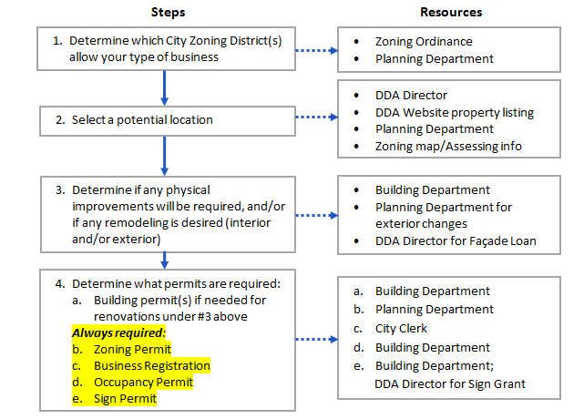

Location, Location, Location
The City Zoning Ordinance regulates the types of uses that are permitted on all properties throughout the City. If you do not yet have a location for your business, you will need to know which zoning districts to search. If you have a location selected, you should ensure your business is permitted there before you sign any lease or purchase agreement.
What’s the difference between the CBD, and the DDA?

Central Business District (CBD) refers to the zoning designation of most of the core downtown. CBD-1 is the area along Nepessing St. comprised of historic commercial buildings that utilize public City lots and streets for parking, due to lack of on-site parking. CBD-2 parcels are generally located along Park Street and Clay Street and may have on-site parking and/or accessory buildings.

The Downtown Development Authority (DDA) is a volunteer board established under State statute (PA 197 of 1975) to guide development and fund public improvements within a defined Downtown Development District. The DDA offers certain services such as Façade Improvement Loans and Sign Assistance Grants to properties within the DDA District. The DDA strives to promote Downtown Lapeer through community events, publications, social media, and collaboration with other local organizations.

Most of what is considered “Downtown Lapeer” is zoned CBD-1 or CBD-2, Central Business Districts. Other property within the DDA Development District, which extends beyond the core downtown, contains different zoning designations. A listing of all the uses
permitted in each zoning district can be found in the City Zoning Ordinance which is available on the City of Lapeer website: http://www.ci.lapeer.mi.us/ZoningOrdinance2.htm. If your proposed use is not listed, please contact the City Planning Department for assistance.

Interior building renovations
Once you have a property selected, please contact the City Building Department to determine if any physical improvements will be required to bring the property up to current building code standards, and if any permits will be required to complete those improvements. Also, please be aware that if you are planning interior renovations that are NOT required, permits may still be necessary; please contact the Building Department for information.

Exterior building changes
If you are planning any exterior building changes please be aware that the City Zoning Ordinance contains standards for exterior building design and materials (Section 7.15.01.) Please contact the Building Department to determine whether or not any permits are needed.

Façade Improvement Loans are available through the DDA for qualifying projects. The DDA must approve all façade designs that will be considered for their Façade Loan Program. Please contact the DDA Director or visit www.downtownlapeer.com for information and assistance.

Signage
Most signs require a permit from the Building Department. The Zoning Ordinance contains a section on signage, Article 7.17, which contains information on permitted and prohibited types of signs. Questions can be directed to the Planning Department or Building Department.

The DDA has a Sign Assistance Grant available to help offset the cost of qualifying signage. Please contact the DDA Director or visit www.downtownlapeer.com > business for more information.

Participation
Many special events and festivals take place in Downtown Lapeer throughout the year, such as Classic Car shows, Farmer’s Market, Art Fair, Halloween Treat Walk, and Winterfest, to name just a few. The Downtown Development Authority (DDA) coordinates many of these events. Other events such as the annual Ice Cream Social, Family Fun Day and Lapeer Days are organized by other groups in the community.

The DDA also manages the Downtown Lapeer website, publishes the Discover Downtown Lapeer brochure, and serves as a liaison to new businesses. Please consider volunteering with the DDA and exploring the many ways to contribute to the success of our downtown.

